CONTRIBUTIONS TO RELIABILITY MODELING AND EVALUATION OF PROTECTIVE STRUCTURE SUBSYSTEMS IN URBAN MEDIUM VOLTAGE ELECTRICITY NETWORKS

FELEA. I.*, ALBUŢ-DANA D.*, PĂCUREANU I.**
*University of Oradea, Universităţii no.1, Oradea,
**S.C. FDEE Electrica Distribution Transilvania Sud S.A - SDEE Braşov
ifelea@uoradea.ro

Abstract - The paper is structured in five parts. In the first part is evoked the importance of the topic and current concerns. In the second part are presented the general pattern of reliability of the relay - the core of the protection subsystems (SSP). In part three are presented the models for evaluation of the proposed development of the reliability of the SSP, based on the general model, given the structure of the SSP and their functions in urban medium voltage electrical networks (UMVEN). In part four are given the results of operational reliability evaluation for SSP as in the last part of the analysis the conclusions are presented.

Keywords: modelling, reliability protection system, electrical network.

1. INTRODUCTION

Reliability analysis and automatic protection system (APS) of UMVEN structure are subordinated to the objectives of maximizing the availability of energy and UMVEN security. By maximizing the availability of energy is obtained also the maximizing of economic efficiency of UMVEN. Sometimes there is a tendency to minimize the importance of APS of UMVEN performance, because they are more reliable than the primary equipment (RPE). In fact, as shown analytically [1, 2, 3, 4, 5], APS and its elements are at a higher level plan in which the RPE and equipment of the structure, the position that "intended" and if necessary, "occur" within the meaning of correct functioning of the RPE and all UMVEN.
In a schematic form, UMVEN of APS integration can be as in Fig. 1.
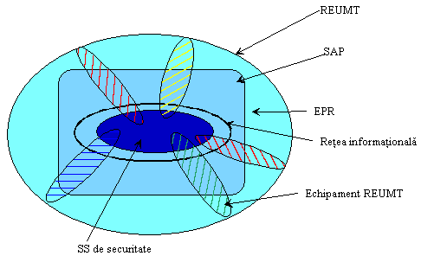
Fig. 1. Schematic representation of UMVEN
and its components
Although APS and its components by its position in UMVEN (tracking and intervention) involves certain features and treatment of reliability approach to conduct these tests should be considered the interference between components of the RPE and APS (Fig. 1) and decisive impact of the reality on the UMVEN performances.
The study of reliability requires a comprehensive approach of the APS related issues. Reliability is treated, from simple to complex as [6]:
- simple relay, as part of itself;
- relay complex consisting of several simple relays;
- protection subsystem (SSP) or subsystem automation (SSA), composed from one or more relays in connection with the complex measuring transformers, current sources and elements of the actuator;
- SSP or SSA and the actuator plus switching device (switch);
- protected element / automated and two cells, which is connected to power system;
- protected element, including "n" cells whose switching equipment, is controlled by APS.
The main specificities in reliability analysis of APS from UMVEN structure result from the operation and features of the failure:
- need to operation request (intermittent);
- by unexpected power failure or refusal of operation.
APS modelling in reliability study of UMVEN may be made only by locating their correct line diagrams of their schemes and correct analysis of the effects of their operation or malfunction.
SSP notifies a failure occurring, fault localizing and triggering control switches, which makes the connection between the primary elements of integrity and failure.
Two categories of indicators recommended for APS components [7, 8]

a) Classical indicators (mainstream);
- Probability of good service (safety time): R (t);
- Mean time between the failures: MTBF;
- The probability of rejection (risk of not responding to the request):

$q\left(τ\right)=\frac{λ⋅τ}{2}+γ ;τ\hat{=}\text{MTTR}$ (1)

γ – probability of failure upon request.
- Average number of unanswered requests during the "T":

$ν(T)=ν_{\text{EPR}}(T)⋅q(τ)$ (2)

Classical indices can’t fully characterize the reliability of APS and its components, whereas only refer to refusals ($\overline{\text{RC}}$) and quantifies their effect unexpected operation (INT ≡ false).

b) Complementary indicators
These indicators are intended for full characterization, (along with the classical one) the reliability of APS and its components.
- incorrect operation intensity (ER) of components / subsystems of APS is expressed as:

$λ_{\text{ER}}=λ_{\overline{\text{RC}}}+λ_{\text{INT}}$ (3)

where,
$λ_{\overline{\text{RC}}}$ - intensity events "refusal response to commands" ($\overline{\text{RC}}$);
$λ_{\text{INT}}$ - intensity of transmission of unexpected orders (false).

- Appear risk of events ($\overline{\text{RC}}$, INT):

$q_{j}(t)=1−e^{−\int{λ_{j}(t)\text{dt}}}$ j = {$\overline{\text{RC}}$, INT} (4)

- The statistics about of the reliability of APS and its components, will refer to variables:
t_{j} – operating time without the variables “j”
ν_{i(T)} – number of events of “j” type during “T”, period, where, j={$\overline{\text{RC}}$, INT, ER}
- intensity of failure of ensemble:

$λ_{\text{ANS}}=λ_{\text{EPR}}+λ_{\overline{\text{RC}}}+λ_{\text{INT}}$ (5)

The relay is the heart of the SSP, for which modelling and reliability evaluation of the SSP, that APS is necessary to start from opinions about the reliability of the relay which are generally divided between two different issues pertaining to safety and security [9]. To improve both security and safety tests must be conducted to ascertain appropriate and protection system [10].
Modern digital relays are normally equipped with devices and monitoring of self. Impact on relay performance and expected benefits from the use of these devices are discussed in various papers [11, 12, 13].
There are many methods which can be used to improve the reliability of relay. These include different operating principles, redundancy in the relay, local safety methods and distance. Redundancy method is generally applied because too high costs and its complexity [14]. Reliability of a relay can also be improved by including in the design, monitoring of embedded devices and of self.

2. GENERAL MODEL OF RELIABILITY OF RELAY FROM APS STRUCTURE OF UMVEN (R-APS)

For R-APS is a general pattern of reliability suitable containing five states, presented in Fig. 2, taking into account the two main modes of failure of protective relay, i.e. lack of response ($\overline{\text{RC}}$) operation when needed and when not needed (INT).
R-APS is a major part of his life in an energized state but static. In this state, the relay is "healthy" (working properly), and monitor an RPE. This state (S₁) can be termed "unnecessary and functional relay. The term "functional" refers on the fact that is willing and able to perform its function.
In state S₂, the "functionally necessary" R-APS operates successfully when called upon. In this state, the relay is operating normally and responds to any anomalous condition associated with protected components. Probability associated with this condition is the reliability of the relay.

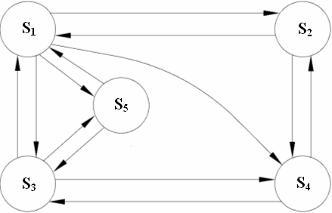
Fig. 2. General model of reliability of relay

In state S₃, the "unnecessary and unworkable",
R-APS is neither requested nor prepared to work. Not required because there has been no damage. Not ready because the relay is either failed or it is subjected to a routine test or inspection of self. This condition can be called state of "unavailability of R-APS.
The S₄ state is called as "necessary and inoperative relay, the relay does not fulfil the function of ($\overline{\text{RC}}$). In this case, failure occurs when the relay is unavailable.
In state S₅, "operation necessary, when the relay operates when doesn’t require to operate (INT). A high probability of being in this state indicates a low safety relay.
States S₃, S₄ and S₅ are considered undesirable and failure states. The main objective is to minimize the probabilities associated with these three states and maximize the protection or operation of probabilities associated with states S₁ and S₂. It is noted that the probabilities associated with S₂ state depend mainly on the rate of failure and recovery time when the fault is isolated RPE.
Typically, statistics on operational reliability of
R-APS refers on states that reflect its failure when it would be necessary (S₄, S₅).
Reliability analysis in the context of R-APS functions that have to refer to a UMVEN RPE leads to the development of reliable detailed model of R-APS operation involving 17 states [10].

3. RELIABILITY MODELING OF SSP OF UMVEN STRUCTURE

The UMVEN uses mainly the following SSP:
- Maximum current protection delay;
- Protection by cutting power;
- Maximum protection from targeted and delayed current;
- Longitudinal and transversal differential protection;
- Distance protection.
In [15, 16] are described in detail SSP and relays used for the various SSP. The general methods are presented in [6, 7, 10], this framework will illustrate the application of forecasting reliability analysis with reference to two SSP.

3.1. Modelling the previsional reliability of the maximal 2 steps current protection (SPMC2)

This SSP is formed [15, 16] by a fast part dedicated to current break (stage I) and a delay part (step II) - Fig. 3.
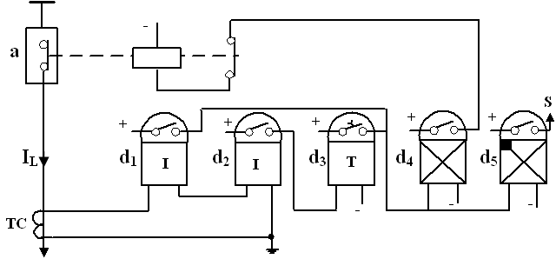
Fig. 3. Scheme of the SPMC2

In table 1 are given the correlations between specific states of general reliability model (Fig. 2) and structural elements SPMC2 states.

Table 1. Impact of SPMC2 element states on general states of SPMC2
General states of SPMC2 |  | States of EPR  State structural elements witch causing general state of SPMC2
Marking | Significance
S₁ | Unnecessary and functional | I_{L} < I_{PII}  Element is operacional: TC.  The other elements are functional.
S₂ | Necessary and functional (in operation) | If: I_{L} ∈ [I_{PII}, I_{PI}]  Work: TC, d₂, d₃, d₄.  Not work (not action) d₁ but is functional.  If: I_{L} ≥ I_{PI}  Work: TC, d₁, d₄.  Are working: d₂ and d₃. relay d₂work (action) but d₄ does not realize action time.  In both cases d₅ is functional.
S₃ | Unnecessary and unfunctional | I_{L} < I_{PII}  Any element failed (unoperational
S₄ | Necessary and unfunctional | If: I_{L} ∈ [I_{PII}, I_{PI}]  Any of elements TC, d₂, d₃, d₄, are unoperational (failed)  If: I_{L} ≥ I_{PI}  Any of elements TC, d₁, d₄, are unoperational (faults).
S₅ | Unexpected operation | I_{L} < I_{PII} and  failed TC (short-circuit in secondary winding)  or  Failure (unexpected action) one of relays d₁, d₂, d₃, d₄.
I_{PI} – current of starting (activation) in step I;
I_{PII} - current of starting (activation) in step II.
SPMC2 has the following functions:
- f₁ – short circuit current referral;
- f2 – data processing and activation of corresponding step;
- f₃ – control of switcher (a).
Basing on the above mentioned functions (f₁, f₂, f₃) may be developed the previsional reliability analyses by using the state graphs, similarly to analyze presented for AAR. To evaluate the provisional reliability of SPMC, basing on the events tree and failures, is suggestive and expedient.
In this procedure will be presented on example referring on the undesired event “unoperation SPMC2 in step I (Quick) fig.4.

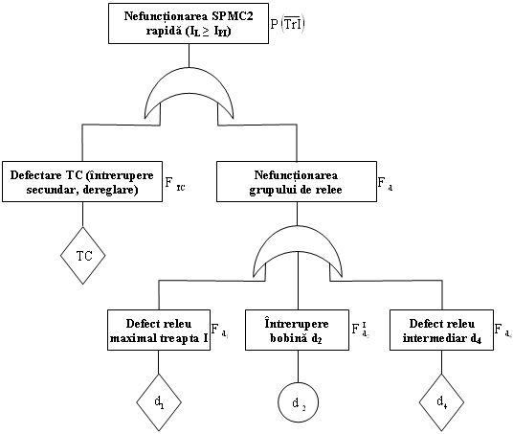
Fig. 4. Tree of events and failures for SPMC2 referring on undesired event “unoperation of fast protection”

To evaluate indicator "F_{d}", referring on relays d₁ and d₄, are taken into account all modes of failures, as referring on d₂ is taken only the failure mode, wire “break” when is the current is also broken through the coil of d₁ relay.
It is obtained:

$F_{d}=F_{d_{1}}+F_{d_{2}}^{I}+F_{d_{4}}$ (6)
The probability of the undesired event;

$P\left(\overline{T_{r}I}\right)=\text{Pr}\text{ob}\left(\overline{\text{TC}}∪\overline{d}\right)=F_{d}+F_{\text{TC}}−F_{d}⋅F_{\text{TC}}$ (7)

3.2. Modelling the previsional reliability of PDLCC

The differential longitudinal protection is realized in two variants [16, 17]:
- with currents of circulation (PDLCC), when it is made a comparison of the currents sense against the two ends of the line;
- with voltage balancing (PDLET), when the voltage drops are compared at the terminals of some resistors, mounted in the secondary of the TC of the two lines.
The diagram of PDLCC is given in fig. 5.

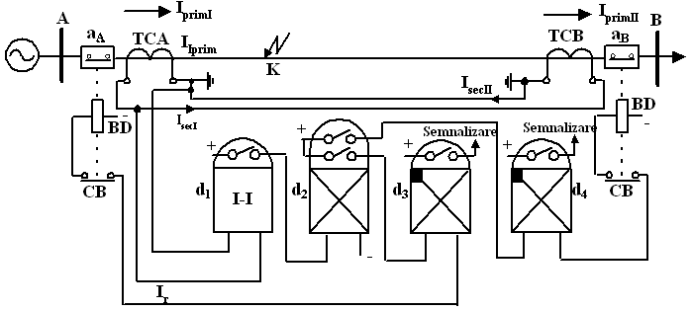
Fig. 5. Diagram of PDLCC

The functions PDLCC are similarly to other APS:
f₁ – referral of short circuit ($I_{r}≥I_{\text{pr}}$);
f₂ – processing and transmitting of information;
f₃ – adequate control of switchers (a_{A}, a_{B}).
In table 2 is presented the correspondence between the specific states of the general reliability model (fig.1) and the states of structural elements of PDLCC

Table 2. Impact of PDLCC elements state on general states of PDLCC
General state of PDLCC |  | State RPE  Structural elements state that provoke the general state of  PDLCC
Marking | Significance
S₁ | Necessary and unoperational | I_{r} < I_{pr}  Operating elements:  TCA, TCB and d₁.  Other elements are functional.
S₂ | Necessary and functional (in operation) | I_{r} ≥ I_{pr}  All elements are in operation.
S₃ | Necessary and unfunctional | I_{r} < I_{pr}  Any element failed (unfunctional).
S₄ | Necessary and unfunctional | I_{r} ≥ I_{pr}  Any element is unfunctional (failed).
S₅ | Intempestive operation | I_{r} < I_{pr}  Failed a current transformer(short circuit between the wires)  or  Failed (intempestive action) of a relay from (d₁, d₂, d₃, d₄).

I_{r} – current in the relay (d₁);
I_{pr} – the adjusted current for driving of the relay (d₁).

The previsional reliability analyze of PDLCC are made as in the other cases of APS, basing on the structure or by reporting to its function. Will be exemplified the mode of analyse basing on the tree of events and failure, referring on the undesired event „PDLCC is in state S₄” – fig. 6.

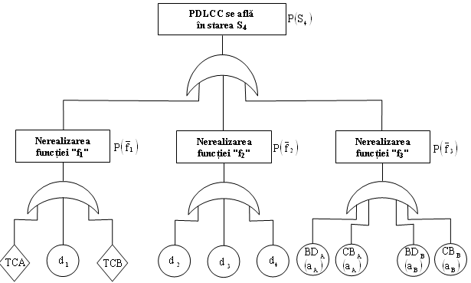
Fig. 6 – Trees of events and failures of PDLCC referring on the undesired events cu „PDLCC is in state of S₄”
The probability of undesired event apparition is:

$P\left(S_{4}\right)=P\left({\overline{f}}_{1}\right)+P\left({\overline{f}}_{2}\right)+P\left({\overline{f}}_{3}\right)$ (8)

where,
$\begin{aligned}\left\{P\left({\overline{f}}_{1}\right)=F_{\text{TCA}}+F_{d_{1}}+F_{\text{TCB}} | \right.\left\{P\left({\overline{f}}_{2}\right)=F_{d_{2}}+F_{d_{3}}+F_{d_{4}} | \right.\end{aligned}$ (9)

4. Assessment of operational reliability of some SSP

By monitoring the operational behaviour of APS serving Brasov SDEE for a period of six year, were determined indicators of operational reliability. In this framework are given a summary of the results, emphasizing the specificities of the SSP. The obtained results wich refere of the performance intensity for each type of protection are sown in fig. 7÷10.
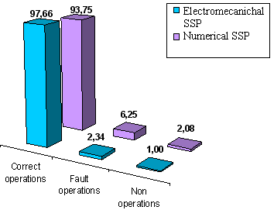
Fig. 7. The performance intensity of the distance protections

We observe a high percentage of performance intensity for numerical protection systems, identified by the study events that may be caused by human error on setting the operation characteristic of numerical protection. Relation to the electromechanically protection systems, the errors results from the distance protection type PD 3/2, which has low reliability, with numerous fault operations, that leads to change this kind of equipment.
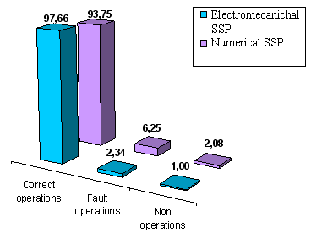
Fig. 8. The performance intensity of the maximal current protections
The study of the maximal current protection identifies a satisfactory functionality of the electromechanically protection systems considering the long functionality time. In case of numerical protections, it considers that from the point of view of advanced technology, the result of the study is not the best. By identify the type of numerical protection with the low reliability; it finds out that the EPAM relays has more fault operations. The problem is solved by sending this relay type to the manufacturer.

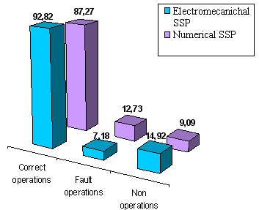
Fig. 9. The performance intensity of the differential protections

In case of differential protections it finds out that in most cases, the faults appears from the secondary circuits fault, like the damage of the cable or contacts.

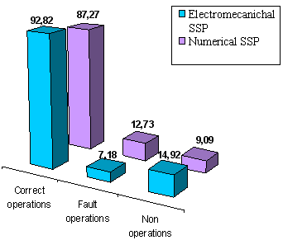
Fig. 10. The performance intensity of the earth protections

By study the functionality of the earth protections it reveals that are more faults operation percentage in case of numerical protections. In this case the errors appear, by analyzing the events, from the incorrect settings applied to the REF-ABB numerical earth protection for resistance compensation. In case of the electromechanically protections, the faults operating are caused by the over aged.
To be estimate the functionality of the protection systems is used to analyze the correct operations intensity, of the fault operations intensity ($λ_{\overline{\text{INT}}}$) and non operations intensity ($λ_{\overline{\text{RC}}}$). These parameters will be determined using the values from the table 1, which refers on the correct operations, the fault operations and non operations for each type of protection, and the followings relations [2]:

$λ_{c}=\frac{\text{Correct} \text{operations} }{\text{Total} \text{equipments}}$ (10)

$λ_{\overline{\text{INT}}}=\frac{\text{Fault} \text{operations} }{\text{Total} \text{equipments}}$ (11)

$λ_{\overline{\text{RC}}}=\frac{\text{Non} \text{operations} }{\text{Total} \text{equipments}}$ (12)

The results are presented in table 4.

Table 4. Comparative study between electromechanically and numerical protection
Protection type | Total installed protection | $$λ_{c}$$ | $$λ_{\overline{\text{INT}}}$$ | $$λ_{\overline{\text{RC}}}$$
Electro mechanic
Distance protection | 57 | 4.65 | 0.18 | 0.05
Max. current protection | 973 | 1.80 | 0.04 | 0.02
Differential protection | 55 | 0.09 | 0.05 | 0.00
Earth protection | 121 | 1.39 | 0.11 | 0.22
Numerical
Distance protection | 5 | 2.40 | 0.40 | 0.00
Max. current protection | 10 | 4.50 | 0.30 | 0.10
Differential protection | 101 | 0.04 | 0.01 | 0.00
Earth protection | 64 | 0.75 | 0.11 | 0.08

5. CONCLUSION

To modelling the previsional reliability of APS, we must start from the fundamental structures of system - relays. Referring on relays, two levels of analyses lends itself to reliability forecast:
- general model, where are evidenced five states and the transitions between them;
- detailed model, there are evidenced 17 states and the transitions between them.
For APS, from UMVEN are possible three variants (levels) of previsional reliability modelling:
- modelling basing on the structure, starting from the diagram of equivalent reliability;
- modelling basing on the functions of UMVEN, based on the state of the graphs;
- analysing the modes of failures, basing on the trees of events and failures.
For each type of SA SSP (maximal of current, differential, distance, etc.) may be stabilized a correspondence between the general states of components and specific general states of any type of relay, as well as between the states of components and SSP function’s degree of satisfaction in UMVEN.
Regarding the operational reliability analyse of SSP in the structure of electric networks managed by SDEE Brasov reflects the followings:
- the electromechanical SSP are majors to all functional kinds, against the numerical SSP;
- the electromechanical SSPs are more reliable as the numerical one, for all functional types: protection on distance, deferential, protection of grounding;
- the numerical SSP destined to maximal current protection are more reliable as the electromechanic SSPs, with the same destination;
- it is necessary to deepen the operational reliability analyses to evidence the failed elements and the failure mode in SSP

REFERENCES

- Anderson, R.T. – Reliability Centered Maintenance, Elsevier, New York, 1990
- Felea, I. – Ingineria fiabilităţii în electroenergetică, Editura Didactică şi Pedagogică, Bucureşti, 1996
- Gebar, T. s.a.. – Fiabilitatea şi mentenabilitatea sistemelor de calcul, Ed. Tehnica, Bucureşti, 1984
- Ivas, D. ş.a. – Fiabilitate, mentenanţă, disponibilitate, performabilitate în hidroenergetică, Editura Prisma, Rm. Valcea, 2000
- *** P.E. 016/84 – Normativ de reparaţii la echipamentele şi instalaţiile specifice industriei energiei electrice şi termice, ICEMENERG, Bucureşti, 1984
- Viziteu, I.– Fiabilitatea sistemelor de securitate cu aplicaţii la protecţia şi automtica instalaţiilor electroenergetice. Teza de doctorat, Iaşi, 1997
- Billinton, R., Allan, R. – Reliability Evaluation of Engineering Systems. Concepts and Techniques, Plenum Press, New York, 1987
- Cătuneanu, V., Bacivarof, I. – Fiabilitatea sistemelor de telecomunicatii, Editura Militara, Bucuresti, 1985
- *** IEEE Working Group D5 on the Line Protection Subcommittee, Power System Relaying Committee,- Proposed statistical performance measures for microprocessor-based transmission line protective relays – Part I: Explanation of statistics, IEEE Trans. Power Delivery, vol. 12, Jan. 1997, pg. 134-143
- Billinton, R., Fotuhi-Firuzabad, M., Sidhu, T., S. – Determination of the optimum routine test and self-cheking intervals in protective relaying using a reliability model, IEEE Transaction on Power Systems, vol 17, no. 3, august, 2002, pg. 663-669 (26.)
- Bennet, A., Webb, A., C. – Computer techniques for the monitoring and testing of modern protecting relays, in Proc. CIGRE Conf., Paris, France, Aug. 1984, pg. 1-6
- Yaguchi, T., Oura, Y., Tsuboi, A., Andow, F. – In-service experience and reliability evaluation of protective relay systems with built-in automatic testing and supervision devices, in Proc. CIGRE Conf. paris, France, Aug. 1984
- Yip, H., T., Weller, G., C., Allan, R., N. – Reliability evaluation of protection devices in electrical power systems, Reliab. Eng., vol. 9, 1984, pg. 191-219
- Grimes, J., D. – On determining the reliability of protective relay systems, IEEE Trans. Rel., vol. R-29, Sept, 1992, pg. 82-85
- Ivaşcu, C.E. – Automatizarea şi protecţia sistemelor electroenergetice, Ed. Orizonturi Universitare, Timişoara, 1999
- *** PE 504/96 – Normativ pentru proiectarea sistemelor de circuite secundare ale staţiilor electrice, Sisteme de conducere şi teleconducere, vol. II
- Ivaşcu, C. - Automatizări şi protecţii prin relee în sistemele electroenergetice, vol. II, Universitatea Tehnică din Timişoara 1992

